RESUME

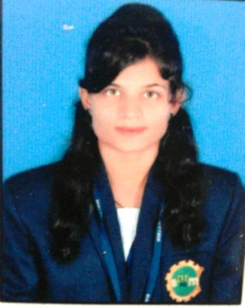
MADHUSMITA MOHANTY
At- Udijohal
Po-Bairoi
Ps - govindpur
Dist- Cuttack
Odisha- 754010
Mob: +91-7735******
Email ID:madhu*****@gmail.com

Career Objective

I aspire to have a challenging and a rewarding position in an organization where I can put in all my efforts out to attain my personal and organization objectives possessing competent technical skills.

Academic Qualification :

Name of Examination | Name of Institution | Board/University | Year of passing | Percentage  of marks
H.S.C | Brahmansailo High school, Brahmansailo | Board of Secondary Education,Odisha | 2013 | 67.33 %
+2 Science | Saraswati Junior Science College, Cuttack | Council of Higher Education,Odisha | 2015 | 59.33%
B.tech(CSE) | Einstein Academy of Tech. & Management, Khurda | BPUT | 2019 | 90%
Computer Knowledge :

- Oracle Database
- Advance Java
- Html
- Css
- Javascript
- php

Seminar/Training:

- ADVANCE JAVA
Institute Name- CTTC, Bhubaneswar
- MSBI- Programming
Institute Name :INTERFACE SOFTWARE
- National Level Seminar on” SOFT COMPUTING, IT’S CURRENT TRENDS AND FUTURE OPPERTUNITIES”
Institute Name- Einstein Academy of Technology and Management, BBSR.
- Seminar on” Recent trends in image processing : 3D modeling” NSRTIP- 2016”
Institute Name- Einstein Academy of Technology and Management, BBSR.

Strength :

- Positive Thinking
- Adaptable to any environment
- Punctual
- Problem solving skills.

Hobbies :

- Reading Newspaper
- Playing Chess

Language Known :

- English
- Hindi
- Odia

Personal Details

- Father’s name : Mr.
- Mother’s name : Mrs.
- Date Of Birth : 01.04.1998
- Gender : Female
- Marital Status : Single
- Nationality : Indian
- Religion : Hindusim
- Permanent Address : At- Udijohal
Po-Bairoi
Ps -govindpur
Dist- Cuttack
Pin- 754010
- Present Address : - DO -

Declaration :

I hereby declare that the above-mentioned information is correct to the best of my knowledge and I bear the responsibility for the correctness of the above-mentioned particulars.

Place : MadhusmitaMohanty
Date : / /Signature

